Anthony Meunier

DeVry University

CIS 355A

Week 3 iLab

InheritanceTest

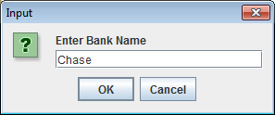

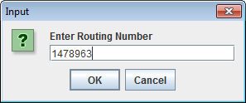

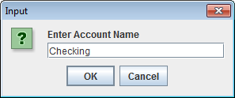

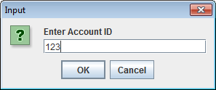

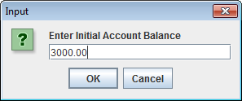

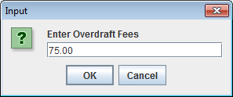

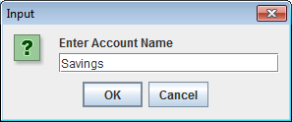

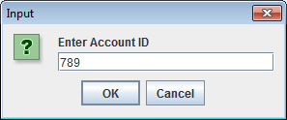

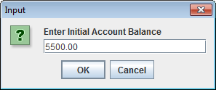

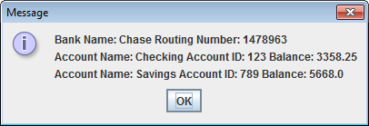

**import** javax.swing.JOptionPane;

/*********************************************

Program Name: Account.java

Programmer's Name: Anthony Meunier

Program Description: Parent class that creates and

instantiates basic attributes, methods, and

constructor for a bank account and processes

transactions such as deposits and withdrawals and

allows user to enter information about the account.

********************************************/

**public** **class** Account {

//Attributes

**public** String AccountName;

**public** **int** AccountId;

**public** **double** Balance;

//Method to accept single double parameter containing deposit amount

**public** **void** ProcessDeposit(**double** depositAmount){

Balance += depositAmount;

}

//Method to accept single double parameter containing withdrawal amount

**public** **void** ProcessWithdrawal(**double** withdrawalAmount){

Balance -= withdrawalAmount;

}

//Method coded as double with empty body

**public** **double** CalcInterest(){

**return** 0;

}

//Constructor to prompt the user and accept input for Account Name, Account ID, and initial balance

**public** Account(){

String AcctName = JOptionPane.*showInputDialog*("Enter Account Name");

**int** AcctId = Integer.*parseInt*(JOptionPane.*showInputDialog*("Enter Account ID"));

**double** balance = Double.*parseDouble*(JOptionPane.*showInputDialog*("Enter Initial Account Balance"));

AccountName = AcctName;

AccountId = AcctId;

Balance = balance;

}

} //End class

**import** javax.swing.JOptionPane;

/*********************************************

Program Name: CheckingAcct.java

Programmer's Name: Anthony Meunier

Program Description: Child class that is derived from

Account class. Will inherit Account class attributes,

methods, and constructor and will also perform

specific function related to "checking" account type.

********************************************/

**public** **class** CheckingAcct **extends** Account {

//Attributes

**public** **double** overDraftFee;

//Method to apply interest rate

**public** **double** CalcInterest(){

**if**((**super**.Balance-overDraftFee) >= 3000)

{

**return** (**super**.Balance-overDraftFee) + (0.01*(**super**.Balance-overDraftFee));

}

**return** 0;

}

//Constructor to prompt the user for the overDraftFee

**public** CheckingAcct(){

**super**();

overDraftFee= Double.*parseDouble*(JOptionPane.*showInputDialog*("Enter Overdraft Fees"));

}

} //End class

/*********************************************

Program Name: SavingsAcct.java

Programmer's Name: Anthony Meunier

Program Description: Child class that is derived from

Account class. Will inherit Account class attributes,

methods, and constructor and will also perform

specific function related to "savings" account type.

********************************************/

**public** **class** SavingsAcct **extends** Account {

//Method to apply interest rate

**public** **double** CalcInterest(){

**if**(**super**.Balance >= 5000)

{

**return** **super**.Balance + (0.04\***super**.Balance);

}

**if**(**super**.Balance >= 3000)

{

**return** **super**.Balance + (0.03\***super**.Balance);

}

**return** **super**.Balance + (0.02\***super**.Balance);

}

} //End class

Greeting

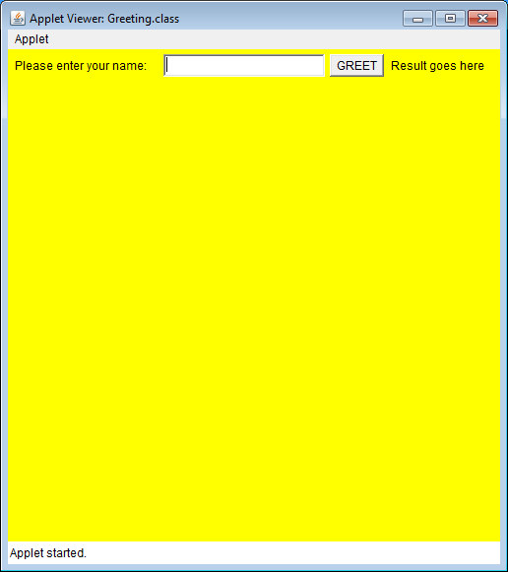

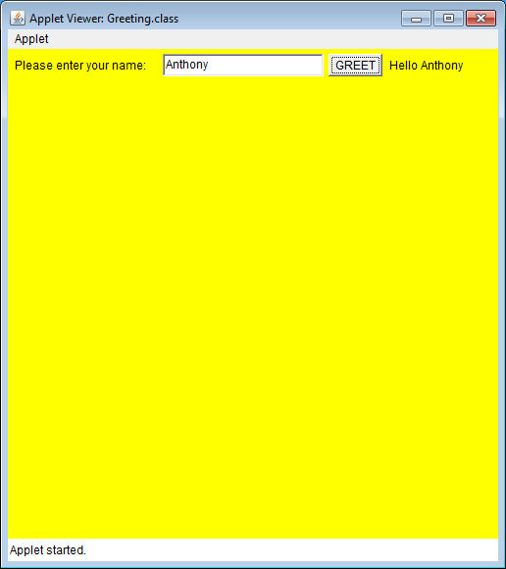

**import** java.applet.*;

**import** java.awt.*;

**import** java.awt.event.*;

/*********************************************

Program Name: Greeting.java

Programmer's Name: Anthony Meunier

Program Description: Creates an applet program

that collects and displays information using

defined settings and implements actionPerformed method

to provide event handling for button click.

********************************************/

**public** **class** Greeting **extends** Applet **implements** ActionListener {

//Create and initialize required objects

Label inputLabel = **new** Label("Please enter your name:");

TextField inputText = **new** TextField(20);

Button GreetButton = **new** Button("GREET");

Label outputLabel = **new** Label("Result goes here");

//Method to initialize what we need for applet

**public** **void** init() {

setSize(500, 500);

setBackground(Color.***yellow***);

add(inputLabel);

add(inputText);

add(GreetButton);

add(outputLabel);

GreetButton.addActionListener(**this**);

}

//Method to provide event handling for button

**public** **void** actionPerformed(ActionEvent e) {

String text = inputText.getText();

outputLabel.setText("Hello "+ text);

}

} //End class